PathFinder AI
Making Indoor Navigation Smarter with Google Gemini
A Case Study | Keerthi V | July 2026
Imagine arriving at a hospital for the first time. A family member needs emergency care, but you don't know where the Emergency Department or the Billing Counter is. Every minute feels important. You ask three different people for directions, follow conflicting advice, and end up on the wrong floor — precious minutes lost in a building that was never designed to be understood by strangers.
That everyday scene — repeated every day in hospitals, colleges, airports, and railway stations around the world — is what inspired PathFinder AI: an AI-powered indoor navigation assistant that lets people simply say where they want to go, in their own words, and be guided there.

The Problem
Indoor spaces are some of the hardest environments to navigate, precisely because the tools that work outdoors don't work inside. GPS signals are unreliable indoors, buildings are added onto over decades without consistent signage, and every visitor is a first-time visitor to someone. The result is a small but constant source of stress and lost time for millions of people every day.

Why It Happens

- No reliable positioning — GPS doesn't work indoors, so mapping apps that people already trust simply stop being useful the moment they walk through the door.
- Signage drifts out of date — Hospitals, colleges, and transit hubs are frequently renovated or extended, so signage lags behind the actual layout.
- Fragmented information — A visitor may need to combine several pieces of information (“which floor,” “which wing,” “which counter”) that no single sign displays together.
- Accessibility is an afterthought — Wheelchair users, the elderly, and people with visual impairments need routes that standard maps don't distinguish from general paths.

Who Is Most Affected
First-time visitors bear the brunt of this problem — patients and families in hospitals, freshers and parents on college campuses, and travelers in unfamiliar airports or railway stations. These are also, not coincidentally, the moments when people are most stressed and least able to spend twenty minutes wandering a hallway.

Why Existing Solutions Fall Short
Static directories and wall-mounted maps assume the visitor already knows the name of the department they need, and they don't adapt to a spoken, natural request like “I need to pay my college fees.” Dedicated indoor-positioning hardware (Bluetooth beacons, RFID) solves precision but is expensive to install and maintain, which is why most public buildings still rely on printed signage alone. PathFinder AI is designed to sit in the gap between these two extremes: no new hardware to install, and no need for the visitor to already know the building's internal vocabulary.

The Solution
PathFinder AI lets users find indoor destinations using natural language instead of manually searching a directory. A user simply says:
“Take me to the Accounts Office.”
The AI understands the request — even if it's phrased indirectly — and guides the user with simple, step-by-step directions to the correct location.

Why Gemini Is Essential
The core challenge PathFinder AI solves isn't drawing a map — it's understanding what a person actually means. Visitors rarely say the exact department name; they describe their situation. Gemini's natural-language and multilingual understanding is what turns a everyday sentence into a precise destination:
What the User Says | What Gemini Understands | Where PathFinder Sends Them
“I need to pay my college fees.” | Intent: payment / fees | Accounts Office
“My father has an X-ray appointment.” | Intent: diagnostic imaging | Radiology Department
“Nearest wheelchair-accessible washroom.” | Intent: accessibility + facility | Accessible Route to nearest washroom
“Where do I catch the Chennai Express?” | Intent: platform lookup | Platform 4, via Gate 2
Table: How Gemini turns a natural request into a concrete destination
Gemini's multilingual support extends this same understanding to users who are more comfortable speaking in their native language, which matters enormously in settings like Indian hospitals, colleges, and railway stations that serve visitors from many linguistic backgrounds. Voice input, meanwhile, removes the need to type or read a directory at all — important for visitors who are in a hurry, carrying luggage, or supporting someone else who needs care.

System Architecture
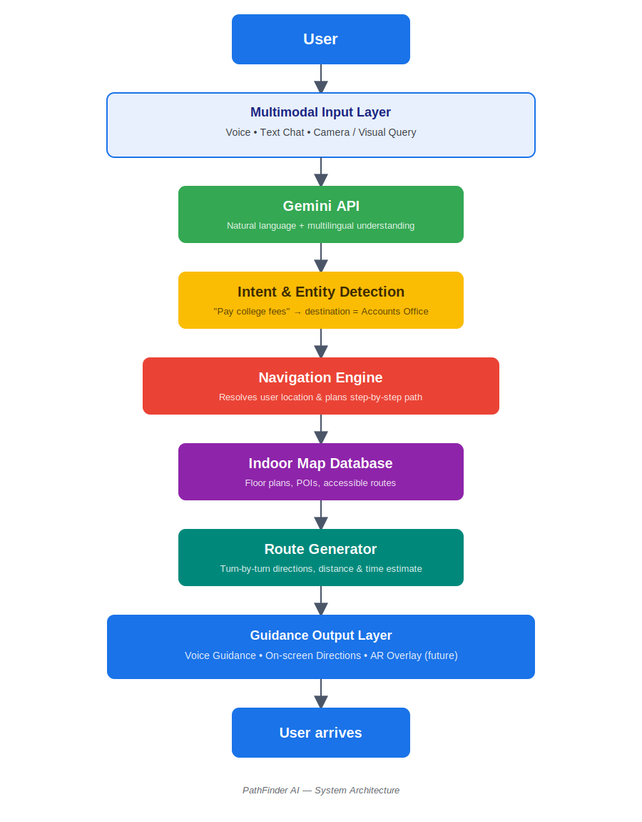
Figure: End-to-end flow from user input to spoken guidance
The request flows through a multimodal input layer (voice, text, or camera) into Gemini for language understanding, then into an intent-and-entity detection step that resolves the request into a concrete destination. The navigation engine combines this with the indoor map database to plan a route, the route generator turns that into turn-by-turn steps, and the guidance layer delivers it back to the user as voice, on-screen directions, or — in future versions — an AR overlay.

Key Features
- Voice Search — Users speak naturally instead of typing or browsing a directory; ideal for visitors who are in a hurry or unfamiliar with the building.
- Indoor Routing — The navigation engine plans a step-by-step path using the indoor map database rather than relying on GPS.
- Landmark-Based Directions — Directions reference recognizable landmarks (“past the pharmacy, turn left”) instead of abstract coordinates.
- Accessibility Options — Routes can be filtered for wheelchair access, avoiding stairs and identifying accessible washrooms and ramps.
- Multilingual Support — Gemini's multilingual understanding lets users interact in the language they're most comfortable with.

Engineering Challenges
- Indoor positioning accuracy — Without GPS, estimating a user's exact position indoors is difficult; the current prototype relies on the user confirming a starting landmark, with sensor-based positioning planned as a future improvement.
- Obtaining indoor maps — Most buildings don't have digitized floor plans, so mapping data has to be manually created and kept in sync as buildings change.
- Multilingual voice recognition — Voice recognition accuracy drops for regional accents and code-mixed speech (e.g., Hindi-English), which required extra testing across languages.
- Privacy considerations — Voice queries can include sensitive context (e.g., a medical appointment), so requests are processed without storing personally identifiable information.

Impact
PathFinder AI can reduce confusion and wasted time for first-time visitors, improve independence and dignity for wheelchair users and people with disabilities, and help hospitals, colleges, and transportation hubs offer a noticeably better visitor experience — without the cost of installing dedicated positioning hardware. In a hospital setting specifically, cutting even five minutes off the time it takes a family member to reach the right department can matter.

Future Improvements
- AR Navigation — Overlaying directions directly onto the camera view for a more intuitive, walk-and-look experience.
- Camera-Based Positioning — Using the phone camera to recognize landmarks and refine the user's position without extra hardware.
- Support for More Buildings — Expanding the indoor map database to more hospitals, campuses, and transit hubs beyond the initial pilot buildings.

Conclusion
PathFinder AI started from a simple, relatable frustration: not knowing where to go inside a large, unfamiliar building at exactly the moment it matters most. By pairing Gemini's language understanding with an indoor navigation engine, the goal is to make finding your way as easy as asking a knowledgeable friend — no directory, no wrong turns, no wasted time. The vision is for PathFinder AI to become a standard companion in hospitals, campuses, and transit hubs, quietly removing one small but very real source of stress from people's days.
PathFinder AI — Keerthi V, July 2026

